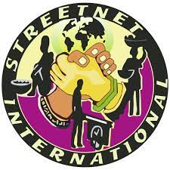



**Motion for a resolution by Côte d'Ivoire affiliates**

*After exchanges and meetings, we, the undersigned members of FETTEI-CI, affiliates of Streetnet International in Côte d'Ivoire, wished that a resolution be taken within the framework of prevention of safety and health at work.*

**1/** Convention 155 was made a fundamental law for the fight against occupational diseases in all sectors of activity by the International Labour Conference of June 2022.

While conducting our various OHS activities, we have observed several cases of occupational diseases among market and street vendors and hawkers and have identified the following risks they are exposed to:

**Risks identified**

* ***Chemical risks***

Exposure to liquids, solids, dusts, vapors and gases;

* ***Physical risks***

Such as noise, vibration, poor lighting, radiation and temperature extremes;

* ***Biological risks***

Such as bacteria, viruses, infected waste and infestations;

* Psychological risks: stress and difficult customers;
* ***Risks related to ergonomics,***

Unsuitable seats and workstations or poorly designed working methods.

**Consequences of occupational diseases**

* suffering due to injury or illness;
* loss of income;
* the risk of losing their job;
* the cost of medical treatment.

In view of all this, we, the workers of Côte d'Ivoire, stand for the imperative adoption of a resolution that will allow the affiliates to create committees within their organization to guarantee the safety and health of our members. For that, we hope that StreetNet will introduce worker education training in OHS prevention in the informal economy with modules adapted to our activities.

**2/** Although our country has not yet ratified Convention 190, we have seen instances of workplace violence involving informal workers.

**3/** We propose that the resolutions for action to be taken by affiliates in each country on the specified date include the 16 days of activities against gender-based violence with regard to women and girls, which start on November 25 (the International Day for the Elimination of Violence Against Women) and end on December 10 (Human Rights Day).

**Done in Abidjan on January 23, 2023**

**On behalf of the FETTEI-CI**

The National President

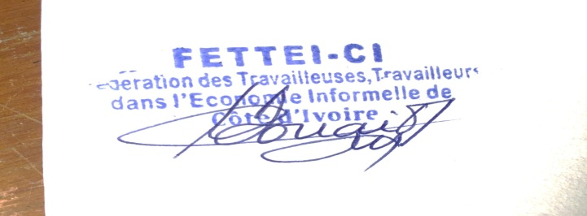

**Mrs. DOUAI Marcelline**